***Software Engineering Assignment***

***Module : 1 (SDLC)***

***Q1. WHAT IS SOFTWARE? WHAT IS SOFTWARE ENGINEERING?***

***A1. Software engineering has two parts: software and engineering. Software is a collection of codes, documents, and triggers that does a specific job and fills a specific requirement. Engineering is the development of products using best practices, principles, and methods.***

***Q2. EXPAIN TYPES OF SOFTWARE.***

***A2.*** T***he two main categories of software are application software and system software. An application is software that fulfills a specific need or performs tasks.***

***Examples and types of software:***

* ***Application software.***
* ***System software.***
* ***Driver software.***
* ***Middleware.***
* ***Programming software.***

***Q3. WHAT IS SDLC? EACH PHASE OF SDLC.***

***A3. Software Development Life Cycle is the application of standard business practices to building software applications. It's typically divided into six to eight steps: Planning, Requirements, Design, Build, Document, Test, Deploy, Maintain.***

***Q4. WHAT IS DFD? CREATE A DFD DIAGRAM ON FLIPKART.***

***A4. A data flow diagram (DFD) is a graphical or visual representation using a standardized set of symbols and notations to describe a business's operations through data movement.***

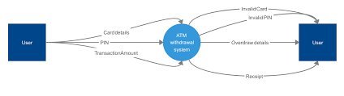

***Q5. WHAT IS FLOW CHART? CREATE A FLOWCHART TO MAKE ADDITION OF TWO NUMBERS.***

***A5. A graphical representation of a computer program in relation to its sequence of functions (as distinct from the data it processes).***

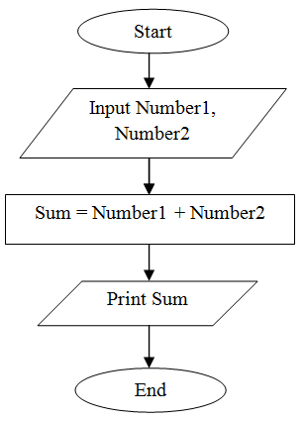

***Q6. WHAT IS USE CASE DIAGRAM? CREATE A USE-CASE ON BILL PAYMENT ON PAYTM.***

***A6. Use-case diagrams describe the high-level functions and scope of a system. These diagrams also identify the interactions between the system and its actors. The use cases and actors in use-case diagrams describe what the system does and how the actors use it, but not how the system operates internally.***

